Iot Based Safety Gadget for Child Safety Monitoring and Notification

**PROJECT REPORT**

***Submitted by***

**AKSHYA K (19EUEC011)**

**ANIRUTH CHAKRAVRTHY N (19EUEC013)**

**ANANDHA KRISHNAN R(19EUEC012)**

**AKASH S (19EUEC009)**

***in partial fulfillment of the requirements for the award of the degree of***

**BACHELOR OF ENGINEERING**

***in***

**ELECTRONICS AND COMMUNICATION ENGINEERING**

**SRI KRISHNA COLLEGE OF ENGINEERING AND TECHNOLOGY COIMBATORE**

**(An Autonomous Institution)**



**ANNA UNIVERSITY: CHENNAI MAY 2022**

**SRI KRISHNA COLLEGE OF ENGINEERING AND TECHNOLOGY**

**(An Autonomous Institution)**

**(Approved by AICTE and Affiliated to Anna University, Chennai) ACCREDITED BY NAAC WITH “A” GRADE**

**BONAFIDE CERTIFICATE**

Certified that this project report titled **“Iot Based Safety Gadget for Child Safety Monitoring and Notification”** is the bonafide work of **AKSHYA K(19EUEC011), ANIRUTH CHAKRAVARTHY N (19EUEC013), ANANDHA KRISHNAN R (19EUEC012), AKASH S (19EUEC009)** who carried out the project work under my supervision.

SIGNATURE SIGNATURE

**Dr.S.SASIPRIYA, Ph.D.,**

**HEAD OF THE DEPARTMENT SUPERVISOR**

Department of Electronics and Communication Engineering Sri Krishna College of Engineering and Technology Kuniamuthur,

Coimbatore

**This project report is submitted for the Autonomous Project Viva-Voce examination held on …………......**

**INTERNAL EXAMINER EXTERNAL EXAMINER**

**ACKNOWLEDGEMENT**

We express our sincere thanks to the management and **Dr.J.JANET, M.E.,Ph.D.,** Principal, Sri Krishna College of Engineering and Technology, Coimbatore for providing us the facilities to carry out this project work.

We are highly indebt to **Dr.SASIPRIYA S ,Ph.D.,** Head of Computer Science and Engineering for her continuous evaluation, valuable suggestions and comments given during the course of the project work.

We express our deep sense of gratitude to our guide**, Mrs.N KALAIVANI, M.E.,** Professor in the department of Computer science and Engineering for her valuable advice, guidance and support during the course of our project work.

By this, we express our heartfelt sense of gratitude and thanks to our beloved parents, family and friends who have all helped in collecting the resources and materials needed for this project and for their support during the study and implementation this project.

**TABLE OF CONTENTS**

**CHAPTER NO TITLE ABSTRACT PAGE NO**

**1 INTRODUCTION**

1.1 Project Overview

1.2 Purpose

**2 LITERATURE SURVEY**

2.1 Existing problems

2.2 References

2.3 Problem Statement Definition

**3 IDEATION & PROPOSED SOLUTION**

3.1 Empathy Map Canvas

3.2 Ideation & Brainstorming

3.3 Proposed Solution

3.4 Problem Solution fit

**4 REQUIREMENT ANALYSIS**

4.1 Functional requirement

4.2 Non-Functional requirements

**5 PROJECT DESIGN**

5.1 Data Flow Diagrams

5.2 Solution & Technical Architecture

5.3 User Stories

**6 PROJECT PLANNING & SCHEDULING**

6.1 Sprint Planning & Estimation

6.2 Sprint Delivery Schedule

6.3 Reports from JIRA

**7 CODING & SOLUTIONING**

7.1.1 Feature 1 : Login

7.1.2 Feature 2 : Signup

7.1.3 Feature 3 : Home

7.1.4 Feature 4 : Live tracker

7.1.5 Feature 5 : Location history

7.1.6 Feature 6 : Recent notifications

7.1.7 Feature 7 : Change password

7.2 Database Schema

**8 TESTING**

8.1 Test Cases

8.2 User Acceptance Testing

**9 RESULTS**

9.1 Performance Metrics

**10 ADVANTAGES & DISADVANTAGES**

**11 CONCLUSION**

**12 FUTURE SCOPE**

**13 APPENDIX**

# CHAPTER 1 INTRODUCTION

**1.1 PROJECT OVERVIEW**

Child tracking system is an app that can track and monitor the child location. The aim of the project is to create a system to allow the parents to keep track of their kids when their child is out of their view. However, with the child tracking system the parent can track and monitor their child location in just a simple app when the parent is in office. A study on few existing tracking system have been done to gather the information and existing problem.

This project focused on how parents can keep track their children movement to avoid child missing, kidnapping and etc. By using GPS as a tracking tool where it allows to determine the exact location (longitude and latitude) of the children. Every an hour, the location of the children will be recorded in the system to keep track the children.

# 1.2 PURPOSE

The parent is not possible to always stay beside of children as most of the

parents needs to go for work. By having this child tracking system, parents can track the

location of their children. Using GPS as a tracking tool where it allows to determine the

exact location (longitude and latitude) of the children. The technology can allow parents

to track child whereabouts. Parent can keep track their children movement when they

were at outdoor and also current location of the child.

# CHAPTER 2 LITERATURE SURVEY

# 2.1 EXISTING PROBLEM

“Nowadays, crimes always occur. This scenario not involves by adults only,

but also happen to children. Parents concern more about serious cases such as missing

children, abduction and rape.The crime also involve by school children have been reported

in newspapers. Although the school have guards that posted on school grounds 24 hours

a day, that simply not enough to monitor the student. To overcome these problems the

authorized need to provide additional security measure”

“Some parents do not have the privilege to send or fetch their children at school.

Parents usually give a hundred percent of trust to their children to travel themselves. Those

children would have to travel by bus, bicycles or walking. Children who travel to and from

school by themselves without monitor by their parents are exposed to danger along the

way.” Besides that, parents usually received late information if anything happen to their

children such as accidents or involved in criminals.

# 2.2 REFERENCES

[1] (Omer & Abdullah, 2013)Omer, E., & Abdullah, M. F. A. (2013). GPS

and SMS-Based Child Tracking System Using Smart Phone. Internasionala Journal of

Electrical, Computer, Electronic and Communication Engineering, 7(2), 171–174.

[2] (Pawade & Gaikwad, 2015)Pawade, R. H., & Gaikwad, A. N. (2015). Android

Based Children Tracking System, 4(6), 2088–2092.

[3] (Pham, Drieberg, & Nguyen, 2013)Pham, H. D., Drieberg, M., & Nguyen, C.

C. (2013). Development of vehicle tracking system using GPS and GSM modem. In 2013

IEEE Conference on Open Systems, ICOS 2013 (pp. 89– 94).

https://doi.org/10.1109/ICOS.2013.6735054

[4] (Rycroft, 1997)Rycroft, M. J. (1997). Understanding GPS. Principles and

applications. Journal of Atmospheric and Solar-Terrestrial Physics, 59(5), 598–599.

https://doi.org/10.1016/S1364-6826(97)83337-8

[5] (Sarjana & Ii, 2012)Sarjana, P., & Ii, M. (2012). GSM & GPS BASED SCHOOL

KIDS TRACKING SYSTEM NG WOON CEA This Report Is Submitted In Partial

Fulfilment of Requirements for the Award of Bachelor Degree of Electronic Engineering

( Industrial Electronic ) With Honours Faculty of Electronic Engineering.

[6] (Salihoglu & Widom, 2013)Salihoglu, S., & Widom, J. (2013). Gps. Proceedings of

the 25th International Conference on Scientific and Statistical Database Management

SSDBM, 1. https://doi.org/10.1145/2484838.2484843

**2.3 PROBLEM STATEMENT**

The parent is hardly to keep a watch on their child without the use of technology, especially when the child is in the outdoor. The parent even cannot avoid the negligence that will make by children in the future day.

There are very limited application available for tracking child when they are out of parents control and let kidnapping or missing cases occurred.

# CHAPTER 3

**IDEATION AND PROPOSED SOLUTION**

* 1. **EMPATHY MAP CANVAS**

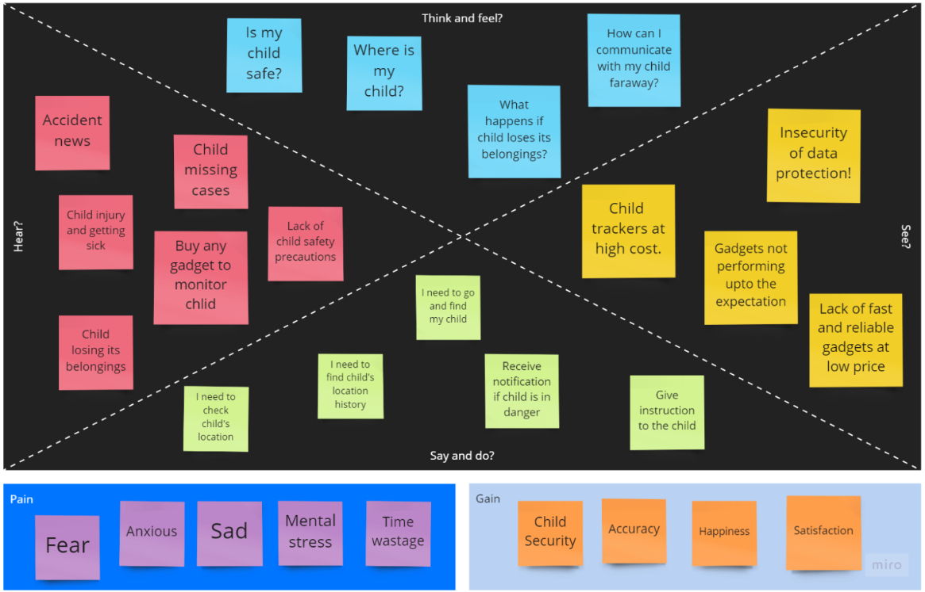

# IDEATION AND BRAINSTORMING

**3.2.1 BRAIN STORMING**

**AKSHYA ANIRUTH**

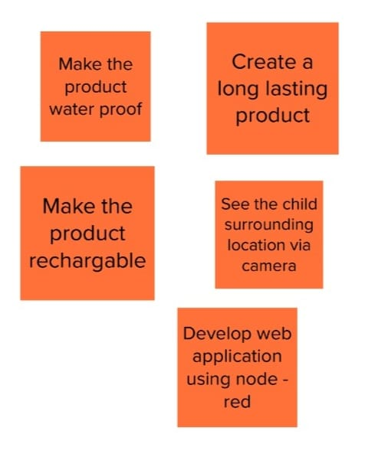

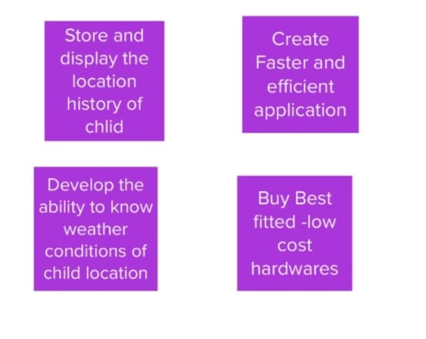

**ANANDHAKRISHNAN AKASH**

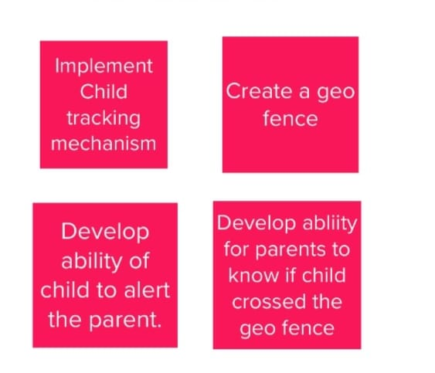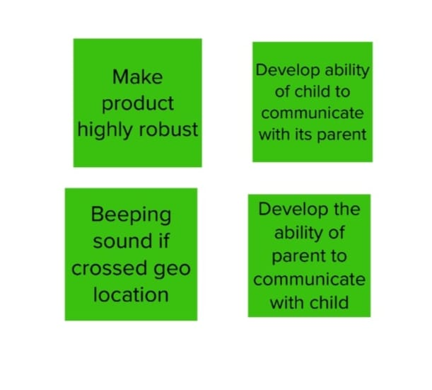

**3.2.2 IDEA PRIORITIZATION** 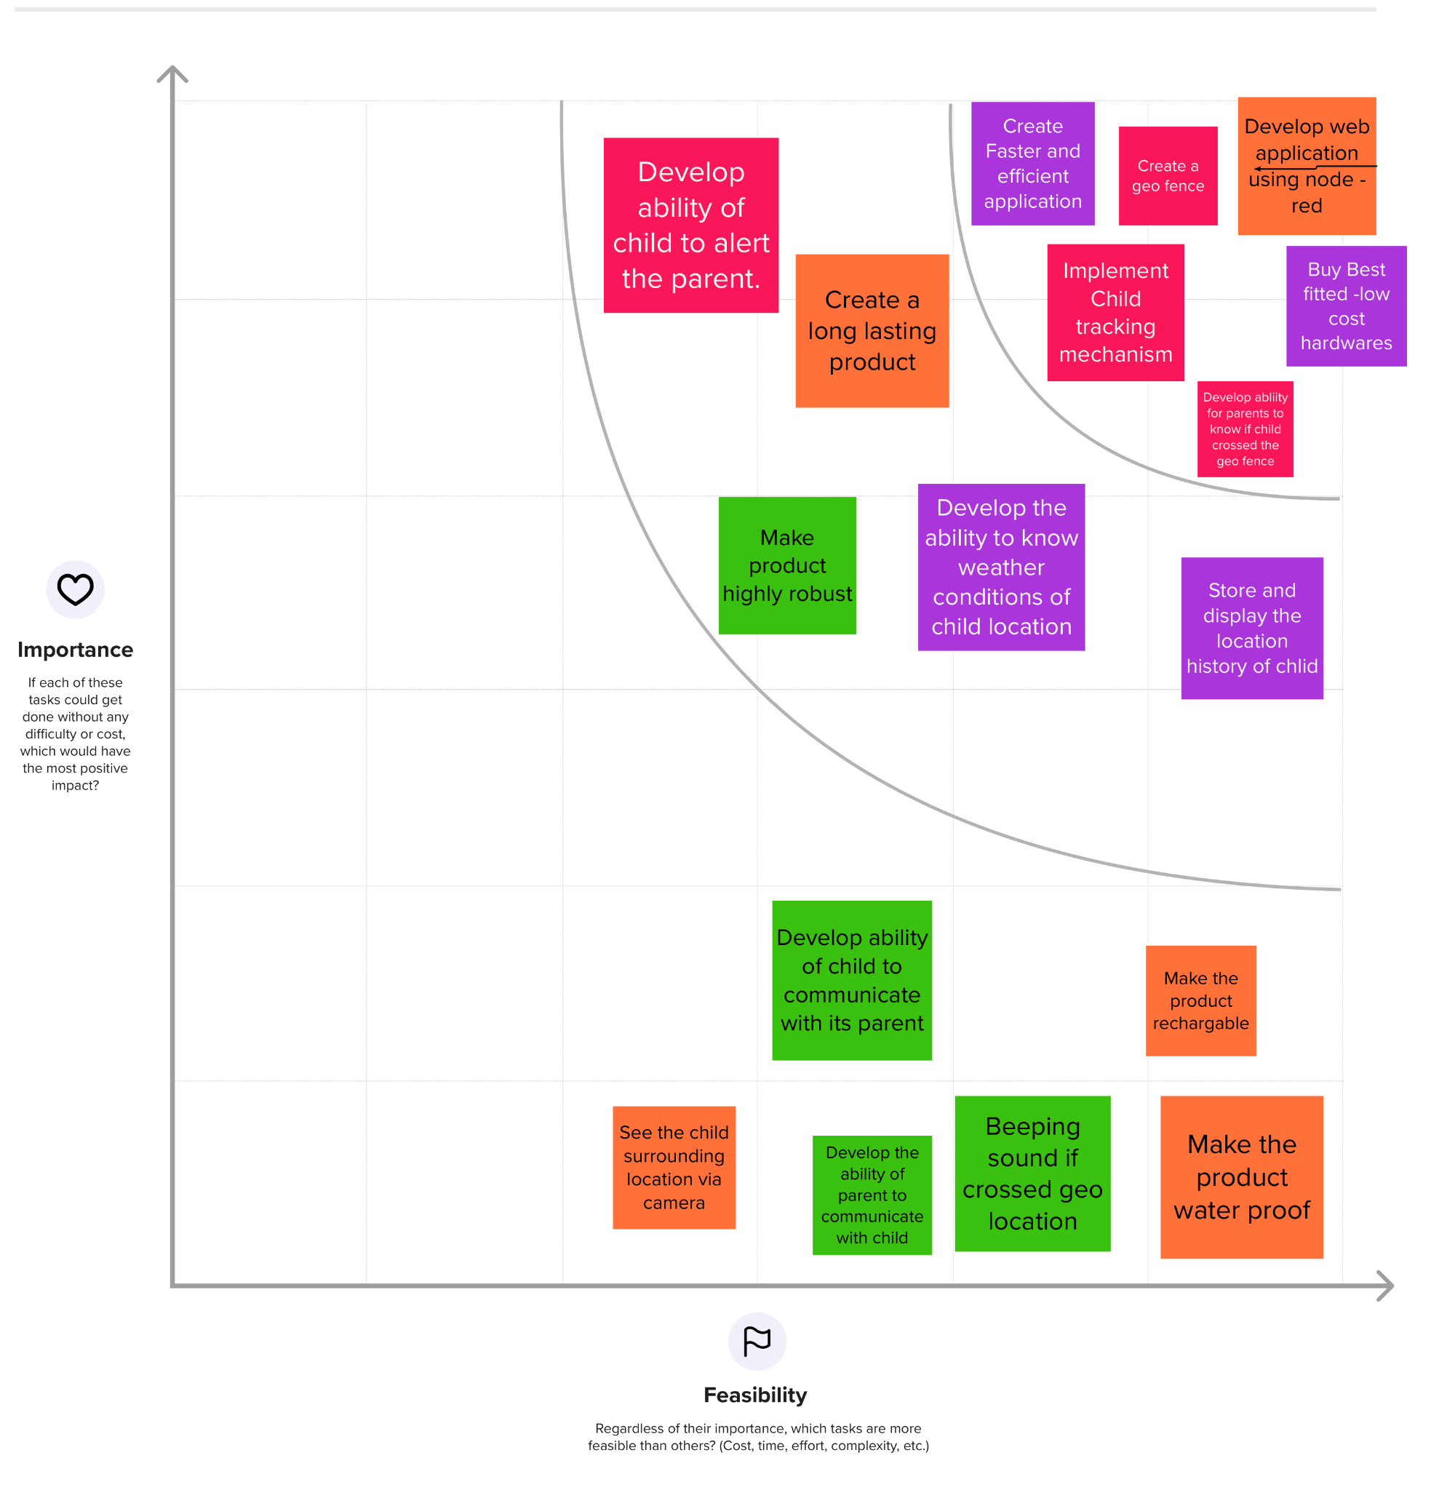

# PROPOSED SOLUTION

|  |  |  |
| --- | --- | --- |
| **S.No.** | **Parameter** | **Description** |
|  | Problem Statement (Problem to be solved) | *As we all know, kids are the heartbeat of every parent, and when it comes to a child with special needs, parents have to be extra careful. They have to take extra care of the child.  *Parents will not be able to monitor their children’s whereabouts at all times and can’t relax without knowing the exact location of them.  *Parents cannot know if their children are in a hazardous or unsafe environment.  *Parents cannot know the previous location history of their children to find any lost belongings of them.  *Parents can neither contact nor instruct their children when they are far away from them. |
|  | Idea / Solution description | *Child tracker helps the parents in continuously monitoring the child’s location. They can simply leave their children in school or parks and create a geofence around the location.  *By continuously checking the child’s location notifications will be provided if the child crosses the geofence. Notifications will be sent according to the child’s location to their parents or caretakers. The entire location data will be stored in the database.  *Child can also initiate emergency notifications to the parents incase of unsafe situation. |
|  | Novelty / Uniqueness | *Easily understandable UI  *Economical  *24/7 monitoring  *Waterproof  *Fast tracking |
|  | Social Impact / Customer Satisfaction | *Cases of child disappearances, kidnapping , child accidents can be reduced drastically.  *Provide liberty for children, especially children with special needs.  *Parents can be relaxed knowing their child’s status especially when they are at a far distance from them.  *Parents can act quickly when their children are in a danger.  *Economical and waterproof features , long - lasting battery and consistent performance of the tracker improves customers satisfaction. |
|  | Business Model (Revenue Model) | *Selling the product directly to the parents(Device + Monthly subscription)  *Selling the product to child care organizations or centers.  *Selling the product via e-commerce. |
|  | Scalability of the Solution | *Increase and decrease of resources like memory and computing power with the help of cloudant db. |

**3.4 PROBLEM SOLUTION FIT**

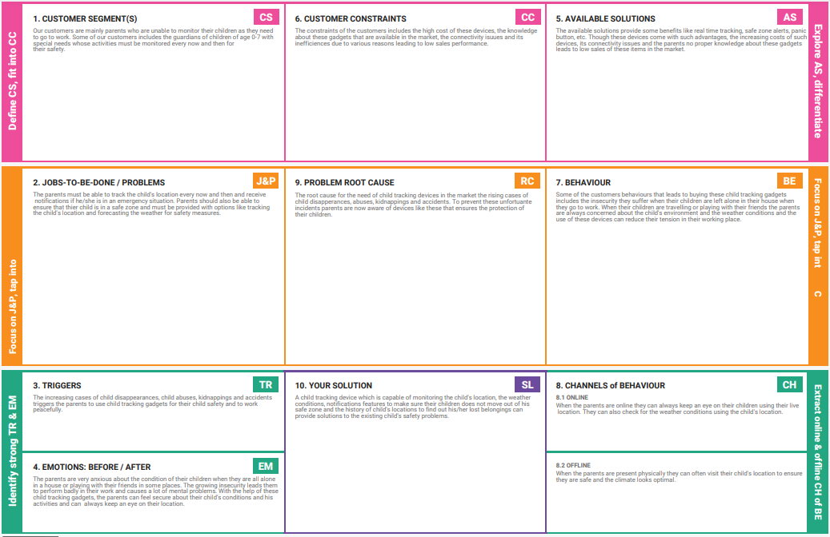

**CHAPTER-4**

**REQUIREMENT ANALYSIS**

# FUNCTIONAL REQUIREMENTS

* The system shall allow the user or family’s to register phone number.
* The system shall provide report for the ongoing day to day activity both for the schools

and families.

* The system should provide all the sensed data from each sensor send by text message.
* The system shall check the sensed data with the threshold value of each input.
* The system shall notify the user while the input value exceed or become below

the threshold value.

**4.2 NON-FUNCTIONAL REQUIREMENTS**

* The system shall give the accurate result for different factors using sensing material as

a result their will not be any distractive damage.

* The system shall be maintainable whenever faller occurs.
* Sometime the GPS module works on rainy condition.
* The system is cost effective comparing to the features it provides.
* The system shall be usable within a few minutes training.

# CHAPTER 5

**PROJECT DESIGN**

**5.1 DATA FLOW DIAGRAM**

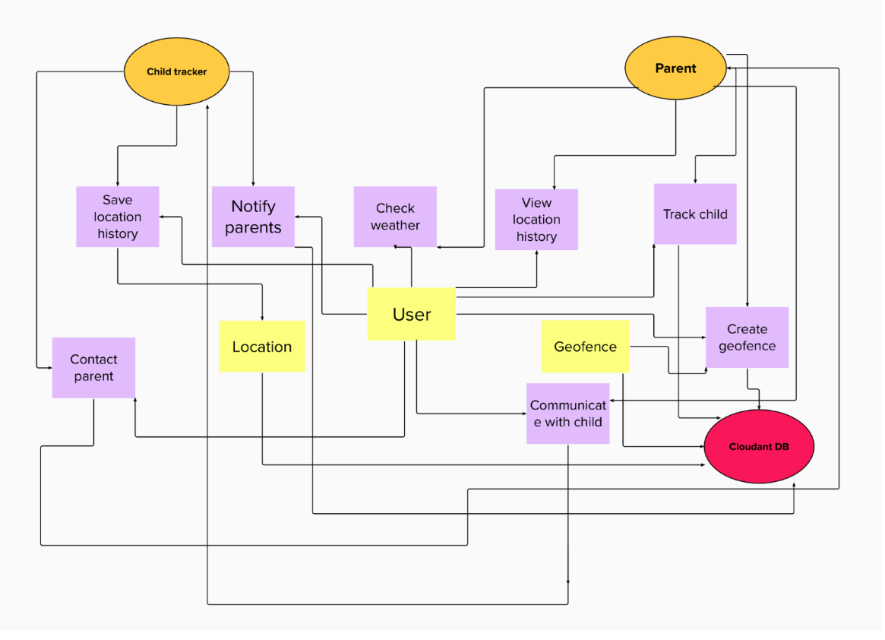

**5.2 SOLUTION AND TECHNICAL ARCHITECTURE**

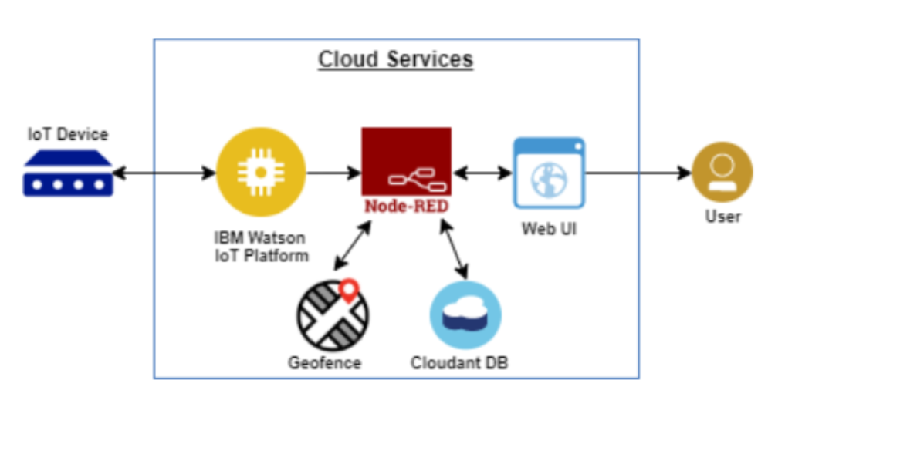

**IoT Device :**

IoT devices are the non standard computing devices that connect wirelessly to a network and have the ability to transmit data. Here we use IoT devices like microcontroller , sensors for input and buzzers , LED light for output.

**IBM Watson IoT Platform :**

Clean and simple UI where you can simply add and manage the devices and control access to the IoT devices and monitor the usage of the devices. Here we add up all the devices that our application need , monitor them and connect with api calls to the node - red platform.

**Node - RED :**

Node - RED is a programming tool for wiring the hardware , API and online services in new and interesting ways. It is a low code platform where you can easily create the application by just drag and drop . We can keep on adding features to our application without worrying about the internal operations. In our application , node red helps to interact with the db (Cloudant db) , store and manage data in the cloud db.

**Geofence :**

A geofence is a virtual perimeter of a real world - geographical area . A geo world can be dynamically created or match a predefined set of boundaries. In our application , the geo fence is created by the parents using node - red.

**Cloudant DB :**

Cloudant is an IBM software product, which is primarily delivered as a cloud-based service. Cloudant is a non-relational, distributed database service of the same name. Cloudant db is the datastore where we store every data of this application.

**Web UI :**

Web is a place where every device in the internet can communicate with each other. Web UI is the application layer for our application where users can interact with their devices , monitor their child , check the location history and check the future and current weather conditions of the child location.

**User :**

User can be parents or guardians who are responsible to monitor the chlid.

**5.3 USER STORIES**

| **Functional Requirement (Epic)** | **User Story Number** | **User Story / Task** | **Story Points** |
| --- | --- | --- | --- |
| Web application flows | USN-1 | Create web application for the user using Node - red without connection to database and devices connected using watson IoT platform. | 20 |
| Session handling | USN-2 | Session handling in the web application. | 20 |
| Connect web application to db | USN-3 | Connect web ui with backend db(Cloudant). | 20 |
| Simulate the hardware devices | USN-4 | Do the virtual hardware connection to web application via watson IoT. | 20 |

**CHAPTER 6**

**PROJECT PLANNING AND SCHEDULING**

# SPRINT PLANNING AND ESTIMATION

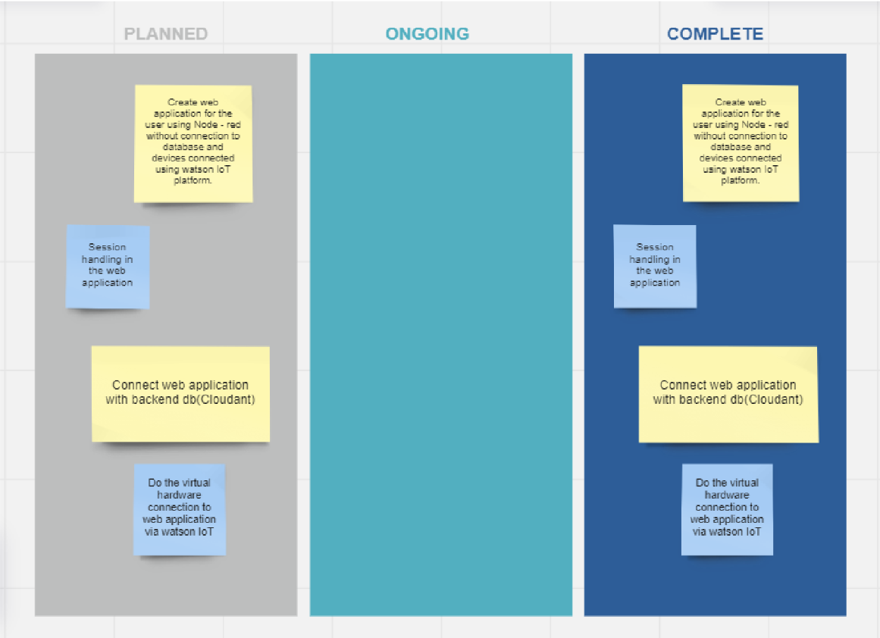

**6.2 SPRINT DELIVERY SCHEDULE**

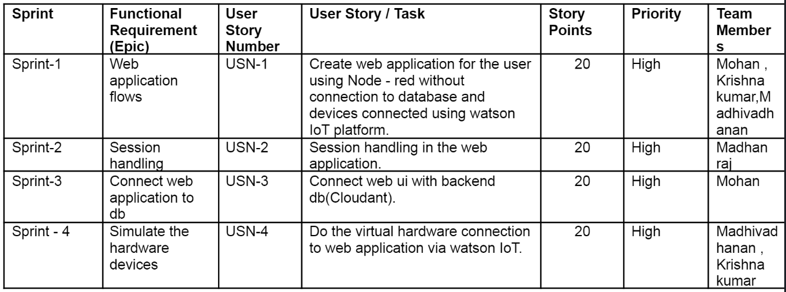

**CHAPTER 7**

**CODING & SOLUTIONING**

**7.1.1 FEATURE 1 : LOGIN**

**Algorithm :**

1. Enter the credentials and hit enter (email and password).
2. If already logged in user is taken to home page
3. Else , check for validity of credentials entered using query to cloudant db.
4. If wrong credentials entered , notification displayed to user and user stays in login page.
5. On correct credentials , user is taken to home page.

**Login checker :**

if(msg.req==null){

email = msg.payload.email;

}

else{

var email = msg.req.params.email;

}

msg.enteredPassword = msg.payload.password;

msg.payload={

"selector":{

"email":{

"$eq":email

}

},

"fields":["email","password"]

}

return msg;

**7.1.2 FEATURE 2 : SIGNUP**

**Algorithm :**

1. Enter the signup form fields (name , email , password , re-enter password , date of birth ) and hit enter.
2. All credentials are validated at client side.
3. Email is checked if already registered or not in the database.
4. If already registered , notification displayed. Or else, the user is taken to the successful signup page.

**Query to check if email is registered or not :**

var email = msg.enteredFields.email;

msg.payload={

"selector":{

"entry-type":"user",

"email":{

"$eq":email

}

},

"fields":["email"]

}

return msg;

**7.1.3 FEATURE 3 : HOME**

**Algorithm :**

1. If the user is logged out , he/she is taken to the login page.
2. Home page buttons are displayed (Live tracker , Recent emergency notifications , Location history , Change password , Logout)
3. If buttons are clicked , the user is taken to the requested page.

**7.1.4 FEATURE 4 : LIVE TRACKER**

**Algorithm :**

1. If the user is logged out , he/she is taken to the login page.
2. GPS sensor data is received via IBM IoT Watson platform , the location marker is displayed in the world map.
3. Location data is stored to db every 1 minute.

**7.1.5 FEATURE 5 : LOCATION HISTORY**

**Algorithm :**

1. If the user is logged out , he/she is taken to the login page.
2. The location table contents are displayed in the table by querying the database.

**Location query getter :**

msg.payload =

{

"selector":{

"entry-type":{

"$eq":"location"

}

},

"fields":["lat","lon","time","description"]

}

**7.1.6 FEATURE 6 : RECENT NOTIFICATIONS**

**Algorithm :**

1. If the user is logged out , he/she is taken to the login page.
2. The notification table contents are displayed in the table by querying the database.

**Recent notification getter :**

msg.payload =

{

"selector":{

"entry-type":{

"$eq":"notification"

}

},

"fields":["lat","lon","time"]

}

**7.1.7 FEATURE 7 : CHANGE PASSWORD**

**Algorithm :**

1. If the user is logged out , he/she is taken to the login page.
2. User is asked to enter the new password twice and click the change password button.
3. Passwords are validated , and password of requested user is changed by querying the database.

**7.2 DATABASE SCHEMA**

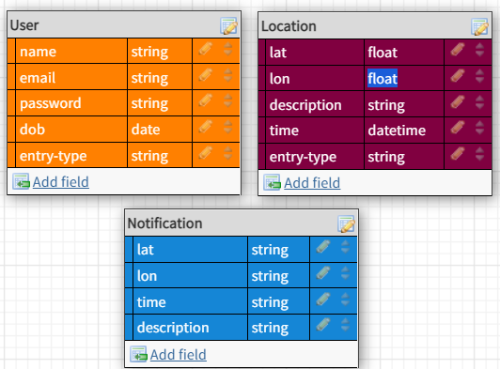

**CHAPTER 8**

**TESTING**

**8.1 TEST CASES**

1. Login button click with wrong credentials entered.
2. Signup with already registered mail ID.
3. Signup with wrong form data entered.
4. Entering home page with logged out session.
5. Clicking home page buttons with logged out session.
6. Invalid data entered in change password page and requested for change in password.

**8.2 USER ACCEPTANCE TESTING**

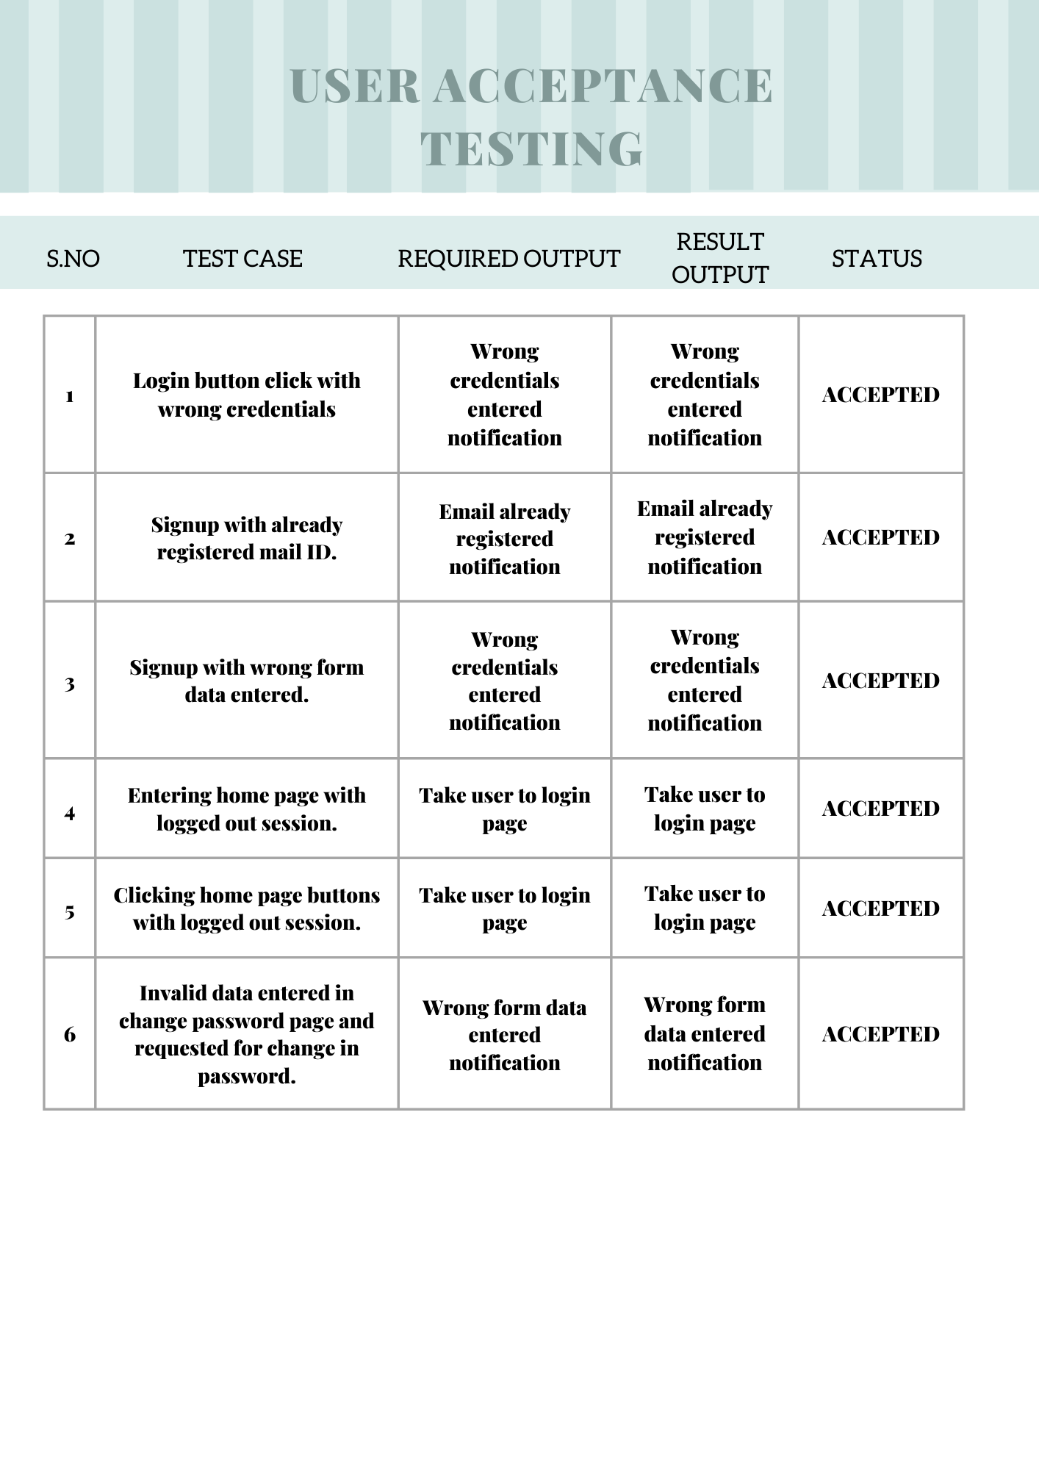

**CHAPTER 9**

**RESULTS**

**9.1 PERFORMANCE METRICS**

1. Planned value : Rs.4000
2. Actual value : Rs.1300
3. Hours worked : 50 hours
4. Stick to Timelines : 100%
5. Stay within budget : 100%
6. Consistency of the product : 75%
7. Efficiency of the product : 80%
8. Quality of the product : 80%

**CHAPTER 10**

**ADVANTAGES AND DISADVANTAGES**

**ADVANTAGES :**

1. Low cost.
2. Simple UI.
3. Faster response due to single page web page.
4. Capability of adding many features with ease and less cost.

**DISADVANTAGES :**

1. Lack of efficiency . Efficiency of the product needs to be improved.
2. Consistency of the product is not 100%.
3. Not a compact sized product. Size needs to be decreased.

**CHAPTER 11**

**CONCLUSION**

The product can be easily made into a business model. With the help of this product, customers can have a happy life , since it is economical and offers a simple user interface to monitor their child . Children can have a safe place to live with the help of this product.This product has the capability of impacting the market if further improvements have been done , due to its low price since , the cost of child safety gadgets in the market is of high cost.

**CHAPTER 12**

**FUTURE SCOPE**

The product can include many other additional features like checking the weather forecast of the child location, interacting with the child etc. If we improve the efficiency of the code and reduce the size of our product , the market will be able to find a new child tracker gadget with low cost and high quality.

**CHAPTER 13**

**APPENDIX**

# INTERNET OF THINGS

The **Internet of things** (**IoT**) describes physical objects (or groups of such objects) with sensors, processing ability, software, and other technologies that connect and exchange data with other devices and systems over the Internet or other communications networks. Internet of things has been considered a misnomer because devices do not need to be connected to the public internet, they only need to be connected to a network and be individually addressable. The field has evolved due to the convergence of multiple technologies, including ubiquitous computing, commodity sensors, increasingly powerful embedded systems, and machine learning. Traditional fields of embedded systems, wireless sensor networks, control systems, automation (including home and building automation), independently and collectively enable the Internet of things. In the consumer market, IoT technology is most synonymous with products pertaining to the concept of the "smart home", including devices and appliances (such as lighting fixtures, thermostats, home security systems, cameras, and other home appliances) that support one or more common ecosystems, and can be controlled via devices associated with that ecosystem, such as smartphones and smart speakers. IoT is also used in healthcare systems.[[10]](https://en.wikipedia.org/wiki/Internet_of_things#cite_note-10)

There are a number of concerns about the risks in the growth of IoT technologies and products, especially in the areas of privacy and security, and consequently, industry and governmental moves to address these concerns have begun, including the development of international and local standards, guidelines, and regulatory frameworks.

# MQTT

MQTT is an OASIS standard messaging protocol for the Internet of Things (IoT). It is designed as an extremely lightweight publish/subscribe messaging transport that is ideal for connecting remote devices with a small code footprint and minimal network bandwidth. MQTT today is used in a wide variety of industries, such as automotive, manufacturing, telecommunications, oil and gas, etc.

# NODE RED

Node-RED is a programming tool for wiring together hardware devices, APIs and online services in new and interesting ways. It provides a browser-based editor that makes it easy to wire together flows using the wide range of nodes in the palette that can be deployed to its runtime in a single-click.

Node-RED provides a browser-based flow editor that makes it easy to wire together flows using the wide range of nodes in the palette. Flows can be then deployed to the runtime in a single-click. JavaScript functions can be created within the editor using a rich text editor. A built-in library allows to save useful functions, templates or flows for re-use.

# IBM WATSON IOT PLATFORM

IBM Watson IoT Platform for Bluemix provides a versatile toolkit that includes gateway devices, device management, and powerful application access. By using Watson IoT Platform, you can collect connected device data and perform analytics on real-time data. The IBM Watson IoT Platform is a fully managed, Cloud-hosted service that provides device management capabilities as well as data collection and management in a time series format. As part of IBM’s Platform as a Service offering, IBM Bluemix, you can use the IBM Watson IoT Platform to rapidly build IoT apps from the catalog of services available in IBM Bluemix. You can choose from such IoT app options as storage services, rules, analytics services, stream analytics, machine learning, visualization, and user apps (Web or mobile). You also can embed cognitive capabilities in your IoT apps by using IBM Watson services available in IBM Bluemix

# CLOUDANT

A fully managed, distributed database optimized for heavy workloads and fast-growing web and mobile apps, IBM Cloudant is available as an IBM Cloud® service with a 99.99% SLA. Cloudant elastically scales throughput and storage, and its API and replication protocols are compatible with Apache CouchDB for hybrid or multicloud architecture.

**PROJECT DEMONSTRATION LINK :** https://drive.google.com/file/d/14jDiOCXGa_5eli6uJCMU0Lr-91AtONt7/view

**SOURCE CODE LINK : https://github.com/IBM-EPBL/IBM-Project-24856-1659950243**